DOCUMENTATION

ASSIGNMENT 3 – DISTRIBUTED SYSTEMS

STUDENT: ANDREEA-LAVINIA GAVRILESCU
GROUP: 30242

CUPRINS

1. The objective of the theme 3
2. Problem analysis, modeling, scenarios, use cases 3
3. Design 3
4. Implementation 3
5. Results 3
6. Conclusions 3
7. Bibliography 3

The objective of the theme

Main obejective
- Develop an Energy Management System comprising a chat microservice and an authorization component. The system should facilitate seamless communication between users and the administrator while ensuring authorized access to the various microservices.

Secondary objectives
- Problem analysis and requirements identification
- Designing the microservice and an associated frontend
- Implementation of the microservice and an associated frontend
- Testing the both the microservice and the frontend

Aproblem analysis, modeling, scenarios, use cases

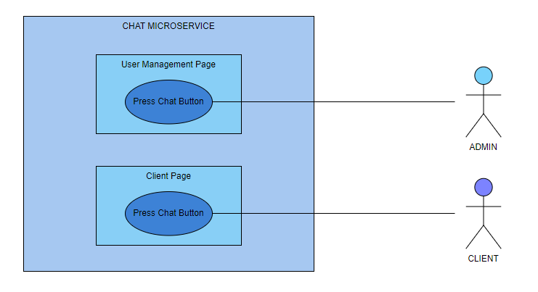

Functional requirements
- The microservices should provide secure authentication.
- The chat microservice should allow an administrator to communicate with clients.
- The chat microservice should allow the clients to communicate with the administrator.
- The frontend should allow the users to perform their actions.
- The frontend should not allow users to access pages where they do not have permission.
- The final application with all the modules should be deployed on Docker.

Non-functional requirements
- The frontend should be interactive and easy to use.

Cazuri de utilizare
- Use case 1: login
Actor: administrator/client
Main scenario
- The user needs to enter valid credentials in the form and press the SIGN IN button.
- The user will be redirected to the next page according to the user role.
Alternative scenario
- The user can introduce wrong credentials.
- The scenario goes back to step 1.

- Use case 2: send messages
Actor: administrator/client
Main scenario
- The administrator needs to go to the User Management / Client page.
- The administrator/client should press the CHAT button in order to open a chat-box and send messages.

- Use case 3: read messages
Actor: administrator/client
Main scenario
- The administrator needs to go to the User Management / Client page.
- The administrator/client should press the CHAT button in order to open a chat-box and read the message by pressing click on the input field. The other user will see that a message was read if the text has a blue line around it.

- Use case 4: typing notification
Actor: administrator/client
Main scenario
- The administrator needs to go to the User Management / Client page.
- The administrator/client should press the CHAT button in order to open a chat-box and start typing a message. The other user will be able to see the user that is typing.

Design

Architecture Diagram
- I will follow a layered architecture, because it separates the application into distinct layers, each responsible for specific functionalities so that a change in one layer doesn't necessarily require modifications in the others.

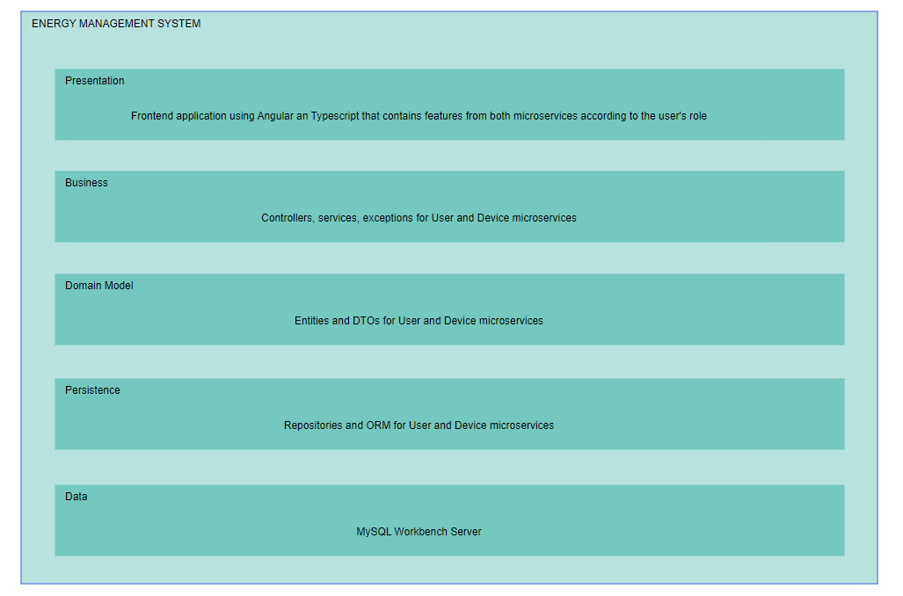

Package division
- Backend packages: domain(entity, dto), repository, service, exception, controller, security and utils (only for User microservice)

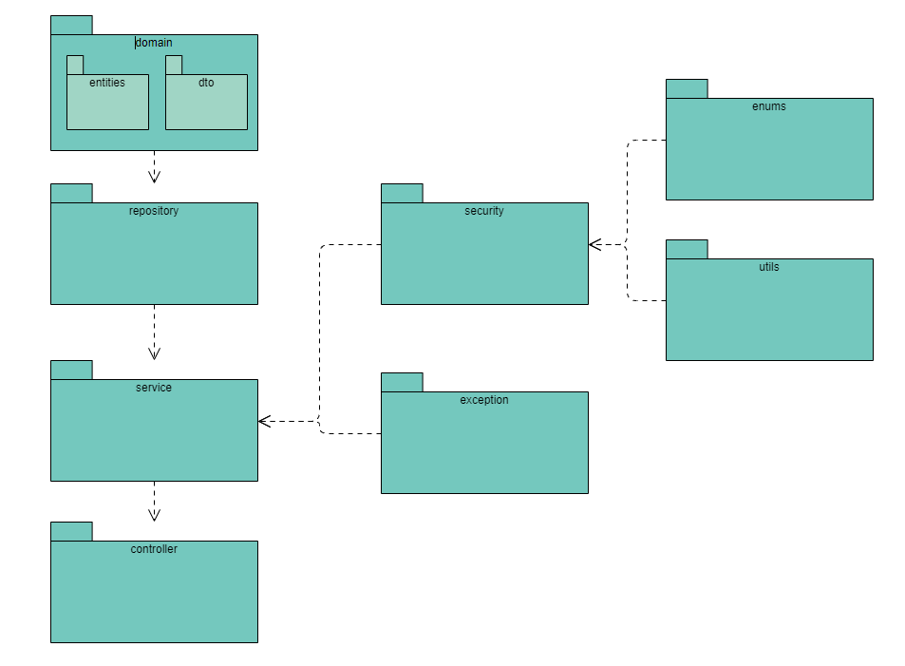
- Frontend structured in the following components: login, navbar, admin-menu, user-options, device-options, mapping options, user-devices
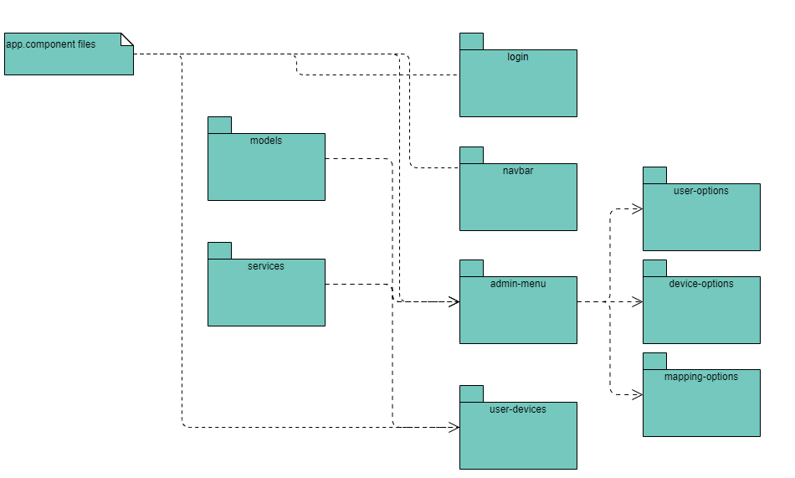

Implementation
For the backend I chose to use Java and Spring as framework.
For the database, I used MySQLWorkbench and Hibernate in order to create tables from my backend applications.
Chat Microservice
- Database
- In this DB there is only an users table that has the following columns: user_id, name, email, password, role.
- Login and security
- For this part I used spring security, more exactly using a JWT token from which I can identify the role of the user and redirect he/she to the corresponding page on frontend.
- Send messages / read messages / typing notification
- WebSockets provide a persistent, full-duplex communication channel between the server and clients.
- By employing WebSockets in the messageReadNotification process, the system achieves real-time updates, ensuring that users promptly receive notifications when messages are read.

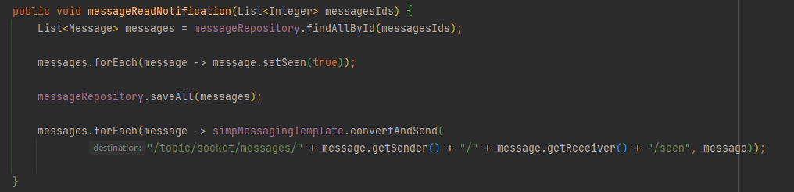

Frontend
- I implemented it using Typescript and Angular as framework. It is structered in components that communicate with each other.
- I intercepted the responses from the backend in the services and then used those methods in my components.
- The user will be redirected to the corresponding page according to its role which I identify from its authorization token.

Docker
- For the deployment of the application I created:
- Two volumes for the DBs and then two containers for the User DB and Device DB.
- A container for each microservice and the frontend application.
- I needed some configurations in my application.yml and then a Dockerfile for each module.
- After creating images and containers from them, my application is hosted on docker now, I only need to start the containers.

Deployment diagram
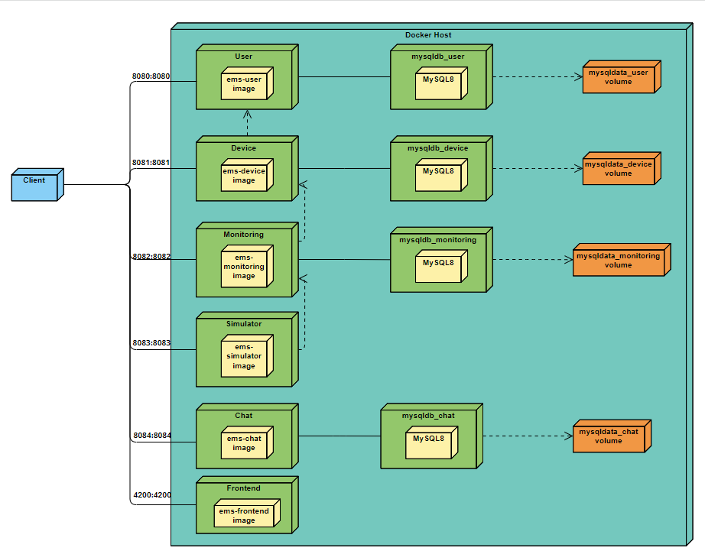

Results
For the testing part I used validation testing, meaning that I tested all the flows following the use-cases and verified if the changes are performed on the DB too.

Conclusions
In this assignment I got the chance to learn about deployment on Docker which I hopefully apply to my license. I also learned how to implement a communication mechanism between two microservices.

Bibliography
- https://docs.docker.com/language/java/deploy/
- https://medium.com/geekculture/how-to-create-and-deploy-docker-applications-1b00e4246c1d
- https://www.baeldung.com/rest-template
- https://www.geeksforgeeks.org/spring-resttemplate/

